

POST-OPERATIVE INSTRUCTIONS: TOOTH EXTRACTION
Please read and follow these instructions carefully
GENERAL INSTRUCTIONS
DO NOT disturb the wound after surgery. Following the extraction of a tooth, a blood clot forms in the site. To prevent post-operative complications, it is important to avoid disturbing the site and follow instructions. A hole may be present initially after extraction. Over the next several weeks tissue will gradually fill the site.
DO NOT smoke or vape for 48 hours minimum. This can cause a dry socket.
DO NOT use drinking straws for 48 hours. This can cause a dry socket.
DO NOT wear retainers or night guards for 48 hours. If necessary, a flipper may be worn the day after surgery though it should be worn as little as possible for the first week.
DO NOT touch the wound or do any vigorous mouth washing on the day of the surgery.
DO keep the gauze pad placed over the surgical area in place for 1 hour. Bite down gently and continuously. If bleeding persists after an hour, the gauze pad should be removed and replaced.
DO take the prescription ibuprofen and over-the-counter acetaminophen (Tylenol) as directed. They work well together. If narcotic pain medication was prescribed that can be taken in place of acetaminophen.
FOOD AND DRINK
Avoid the use of a straw for 48 hours post-surgery. Alcoholic beverages should be avoided for at least 24 hours or if taking narcotic pain medication. Once the bleeding is controlled, you can consume liquids and soft foods. Begin with clear liquids such as apple juice, ginger ale, and broth, and advance your diet in the first day as tolerated. This includes Jell-O, applesauce, yogurt, etc. For one week post-surgery, soft foods are recommended to allow the site to heal. This includes items such as mashed potatoes, scrambled eggs, pasta, etc.
DO NOT eat popcorn, peanuts, seeds, or chips, for at least two weeks after surgery to prevent infection in the surgical site from impacted food debris.
PHYSICAL ACTIVITY
Restrict physical activity the day of surgery and possibly up to one week. Resume normal activities as tolerated.
BLEEDING
Bleeding may persist for approximately 24-48 hours. Slight bleeding, oozing, and redness in the saliva is to be expected. To minimize bleeding bite down on the gauze pad for at least one hour following the procedure. Replace with fresh gauze every 30-60 minutes as needed. For minor persistent bleeding, gauze is not necessary. If bleeding continues, bite on a dry tea bag instead of gauze. Ingredients in tea leaves help promote blood clotting If bleeding persists and is uncontrolled, contact our office immediately.
SWELLING AND BRUISING
Swelling and bruising is normal after surgery. The swelling is usually at its peak 3-5 days after the procedure and may take up to a week to fully resolve. You can apply ice packs over the area at home to minimize swelling and alternate ice packs 20 minutes on, 20 minutes off, for the rest of the day or up to 24 hours. After 24 hours, it is not necessary to continue to ice the area and instead a warm compress can be used.
PAIN
Pain medication should be taken within 1-2 hours after the procedure (before the local anesthetic subsides). For most patients, a regime of prescription ibuprofen (Motrin/Advil) and over-the-counter acetaminophen (Tylenol) is recommended. They are two different medications and are safe to take in combination.
It is advised to take 600 mg of ibuprofen every 6 hours and 1000mg of acetaminophen every 6 hours. These should be staggered for optimal pain relief. For example, at 10am take 600 mg of ibuprofen, at 1pm take 1000mg of acetaminophen, at 4pm take 600mg of ibuprofen and at 7pm take 1000mg Tylenol, etc. This should be continued until post-operative pain has subsided.
If a narcotic pain medication was prescribed, that can be taken in place of the acetaminophen.
Do not operate a motor vehicle or machinery or drink alcohol while taking narcotic pain medication.
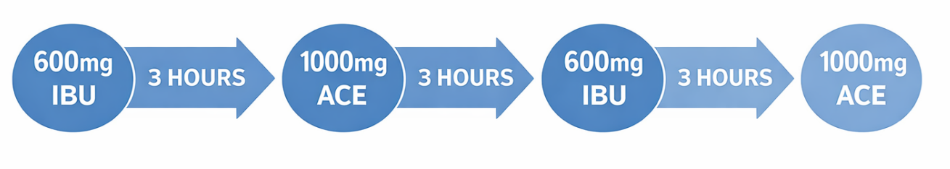
ANTIBIOTICS
If you have been prescribed antibiotics, take the tablets or liquid as directed. In most cases, you will be prescribed a larger dose prior to surgery. On the day of the procedure, you will take the antibiotic two different times. (1) A larger pre-surgery dose and then (2) a normal dose (1 tab) 8 hours later. For example, the larger pre-surgery dose was taken at 8am, the next dose should be taken at 4pm.
Discontinue antibiotic use in the event of a rash or any other unfavorable reaction and contact our office immediately. Please note that women taking oral contraceptives are recommended to use other forms of contraception while taking antibiotics. These medications can temporarily decrease effectiveness.
RINSING
Avoid rinsing on the day of surgery. The day after surgery begin saltwater rinses 3 times per day (1/2 tsp salt in 8oz of warm water). Avoid alcohol-based rinses (ex. Listerine) for 1 week.
SOCKIT GEL SYRINGE (DAY 1)
If provided, the Sockit gel syringes can be used 2-4 times per day starting the day of surgery. Expel the contents on top of the extraction site. Use until contents of the syringe are gone.
EMPTY SYRINGE (DAY 5)
If provided, the empty syringe is to be used after meals starting on post-operative day 5. Draw up warm water and irrigate the extraction site by putting the tip of the syringe within the extraction site and expelling the water. Slight bleeding may occur and that is normal.
BRUSHING/FLOSSING
Normal oral hygiene may resume the day after surgery though avoid brushing/flossing directly on the surgical site for one week.
SUTURES
If necessary, sutures (stitches) may have been used to facilitate wound healing. Dissolvable sutures typically stay in place 7-10 days. If they come out sooner do not be alarmed.

OFFICE INFORMATION
202 S Greenleaf St Ste A, Gurnee, IL 60031
(847) 623-2830

